[Excerpts from] FAQs For Supporting Immigrants in the Aurora GEO Detention Center
Created by Volunteers of Casa de Paz; slightly edited and excerpted by RMIAN on June 14, 2020

Location of original version by Casa de Paz volunteers—occasionally updated by them: http://bit.ly/connecttogeo

How do I learn about upcoming legal proceedings for immigrants in detention?
How do I attend upcoming legal proceedings for immigrants in detention?
How can I send money to immigrants in detention (For commissary or to take w/ them upon exit)?
What are the visiting hours for immigrants at the Aurora GEO Detention Center?
How can I communicate with immigrants in detention and/or send them money for phone calls, messaging with their family, or for you to message with them?
How can I send books to immigrants in detention?
Can we bring a backpack with clothes and other supplies to immigrants who are being deported?
What resources are available for immigrants who are being deported?

How do I learn about upcoming legal proceedings for immigrants in detention?
- Call 800-898-7180, press 1 for English, then press 1 to enter the A#. Then enter the A#, and it will confirm the person’s name. Then it will allow you to get the following information, by number:
- Next hearing date
- Clock – this means how many days have elapsed since the person filed an asylum application, if any
- Decision information – this will normally say if the judge granted relief, denied relief, etc.
- Appeal information – will normally give information regarding an appeal deadline
- The court which has jurisdiction over the case

How do I attend upcoming legal proceedings for immigrants in detention?
- The hearings are held in the GEO detention center, in the same building where we visit immigrants in detention.
- Plan to arrive in the lobby 30 minutes prior to the scheduled start of the hearing.
- You must dress conservatively. No shorts. Women: no sleeveless blouses.
- Check in with the guard and let them know the name of the immigrant whose hearing you are there to visit. Just to be safe, you should bring the A# as well.
- When it's time for the court hearing to start, you'll be taken back to the same area as where visitations are done, but in a different hallway.
- For a bond hearing or master calendar hearing, you should be there at the start of the docket. (Multiple people will be scheduled at the same time.)
- If the judge asks who you are, explain that you are a relative or personal friend of the immigrant in the hearing. Although master calendar and bond hearings are open to the public, individual/merits hearings are not, so you must have the permission of the immigrant to attend.
- The hearings can last from 1 - 4 hours, so if you are planning to attend, you should set aside the entire morning or afternoon. However, if you need to leave early, this is an option.

How can I send money to immigrants in detention (For commissary or to take w/ them upon exit)?
To send money to an immigrant in detention, do the following:
This is money that can the immigrant can use for 2 purposes.
#1 - Commissary (for extra food, coffee etc.)
#2 - They can take when they leave.

Purchase a money order made out to the immigrant and include their A# on the money order.

Mail the money order to the detention center, and address the envelope as follows:
Immigrant Name
A########
3130 Oakland St. Aurora CO 80010

What are the visiting hours for immigrants at the Aurora GEO Detention Center?
Visiting hours for immigrants in the detention center are based on the area of the dorm - or ‘pod’ - where they are staying. To find out the pod of an immigrant, call GEO at 303-361-6612 and ask the guard, who will need to know the name and potentially A# of the immigrant you want to visit in order to find the pod number.

Visiting hours at the detention center are subject to change. Call the front desk at 303-361-6612 for current information.
How can I communicate with immigrants in detention and/or send them money for phone calls, messaging with their family, or for you to message with them?

FYI: Guards may refer to this as Talton.com account. Gettingout and Talton money both go to the same account.
Money may be added 2 ways.
1. Kiosk in the detention center
2. Online : https://www.gettingout.com/

Immigrants can also use this money for ‘Tablet time’ so they can watch movies, listen to music, etc.
There is also a phone app, but some people reported better access via the website. Some parts require Google Chrome to be the browser.

You must have the Last Name and A number of the immigrant.
No spaces in the A Number when entering. If the first digit is a 0, try with the 0 and try without.
You may need to try all last names if the name is hyphenated or has multiple names
Also, just because they are located in one section with one name, they be listed in a different section under one of their other names.

Minimum Deposit looks like $25 but is actually $10 in the Other area.

The app and site are very bad. Be prepared for pages to time out or to get through multiple steps and then have the page crash and you must start over.

Messaging an immigrant in detention
Each message costs 25 cents to send and to receive.
You and the immigrant must both have money in your account.

The new Phone App appears to work much better than the website.
Details to be updated soon.
Phone App Giving Money and Sending Messages
- Download GettingOut App. (Blue one, not GettingOut Visits)
- Create a gettingout account and login.
- Find Immigrant.
  - Go to Contacts ‘Add a Contact’
  - Find Facility
  - Put in Last name and Booking/A Number
  - If you fail to find contact, try middle names as last name, and make sure you have a 0 in front if the A number is only
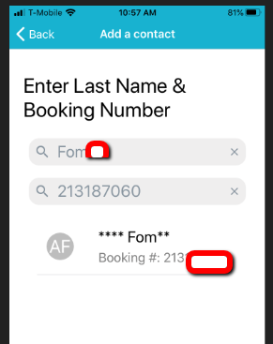.
  - Once located Add Contact
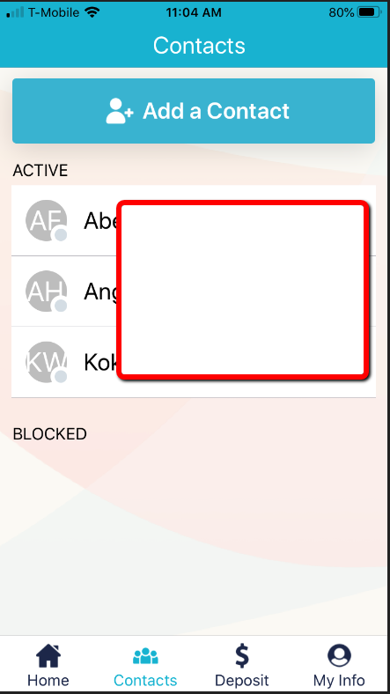
- Go to Deposit and you should see contact and Make Deposit. (min $10) into their ‘Inmate Account’

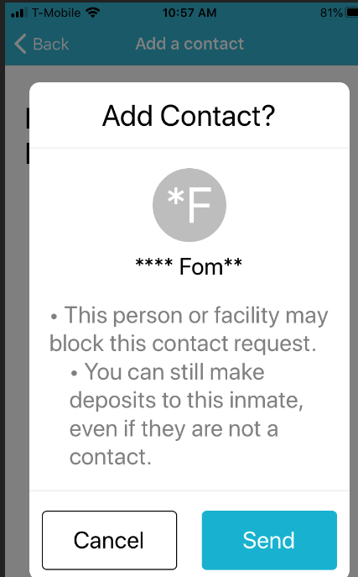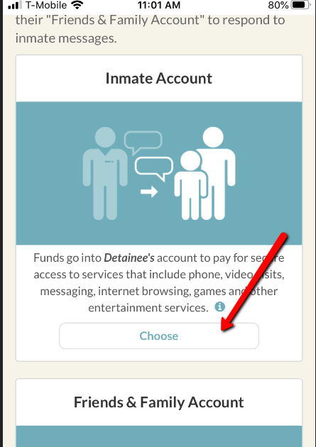
- Go to Deposit and ‘My Account’ and make a deposit into your account. Remember it costs .25 cents for each of you. (min $10)
- Go back to Contacts, click on contact and click ‘Message’
- Send Message. Immigrant won’t be able to see the message until he ‘Approves’ you as a contact.

Website Giving money
- Create a gettingout account.
- Click ‘new deposit and account mgmt system’ link
- Log in again
- Select 'Make a Deposit'
- Choose, Colorado, Aurora
- Select Inmate Account (Friends and Family account, means that they can ONLY use that money to message with you. Probably not what you want)
- Put in immigrants A Number and first three digits of Last Name.
- Enter amount and Credit Card info.

The immigrant has to accept you as a contact before you can message.

Website Steps.
- Create a gettingout account.
- Put in A Number and first three digits of Last Name
- Deposit money in the immigrant’s account.
- Go back to https://visit.telmate.com/user/contacts
- If you only see a name text box (instead of A Number and Name) STOP.
Assuming you already have Aurora as the facility, switch to a different facility, then switch it back. You should now see 2 text boxes. A Number and Name)
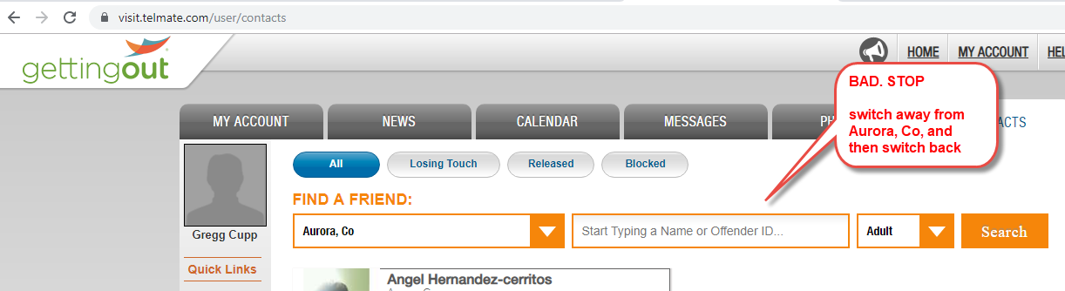
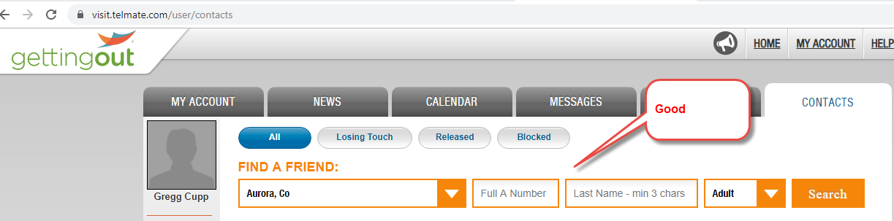
- Schedule a visit. 'Visit Now' button (not video) This will send a message to the immigrant that you want to contact them. If you look at 'My Visits' no scheduled visits will be shown.
- After they 'accept' your contact request, you will receive a notification in the app.
- Deposit money in your account.
- You will then have to confirm your phone number.. They send you a number and you have to reply with that number.
- Then you should be able to see them in your account under contacts and be able to send them a message.

How can I send books to immigrants in detention?
Books must be sent to GEO via a 3rd Party Source. (amazon for instance)
Include the full name of the immigrant and their A# in the address. (You can verify their A number using the ICE Locator System: https://locator.ice.gov/odls/#/index)

The immigrant is more likely to receive the book if it is a softcover book, not hardback.
Also if the immigrant wants to get the book quickly, the immigrant can fill out a KITE request before the book arrives with the title and author.

Address as follows:

Immigrant Name
A########
3130 Oakland St.
Aurora CO 80010

Can we bring a backpack with clothes and other supplies to immigrants who are being deported?
First, call GEO (303-361-6612) to see if the person is allowed to receive a backpack yet (they can only get one if they already have an order of deportation). If the guard says yes, then you can ask what days/times you can bring the backpack (they frequently change)

The backpack can include one of each of these: shirt, pants, coat, socks, underwear, gloves, hat, shoes. They don’t allow anything else like $, toiletries, snacks or books.

If you bring clothes to the detention center, a guard will need to review and document everything that is given to the immigrant, which usually takes a bit of time. Then the guard will mark the bag with the immigrant’s A number and send it with them the day they are deported.

What resources are available for immigrants who are being deported?
- The American Friends Service Committee (AFSC) has compiled extensive resources in English and Spanish for folks who are being deported to Mexico, Honduras, El Salvador or Guatemala.
- Life After Deportation is a guide that gives options for folks who are being deported to Mexico. The target audience is for people who grew up in the US and are being deported to a country that is unfamiliar to them.
- This survival guide gives guidance to immigrants who are being deported to Cambodia.
- Alternative Chance / Chans Altenativ offers guidance for folks who are being deported to Haiti
- This guide - compiled by Freedom For Immigrants - provides post-deportation resources for folks being deported to Mexico, Honduras, El Salvador, Guatemala or Jamaica.

